Server-side Development Project Setup

By Nolan Eitzen

For CIS 530

# VS Code Setup

1. Install Java Extension Pack



1. Install Spring Boot Extension Pack

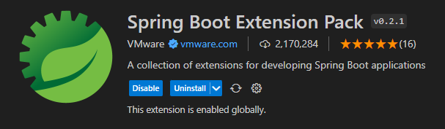

1. Install the Spring Boot Initializer Extension Pack

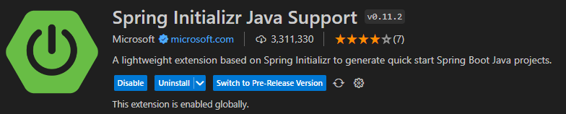

# Creating a new Spring Boot Project

1. Start the Spring initializr using a maven project

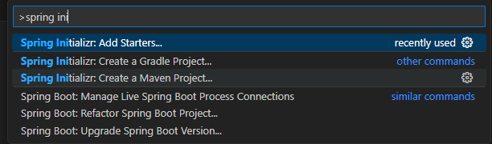

1. Select the latest version

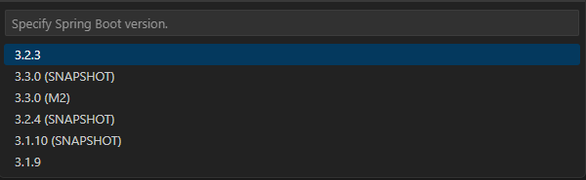

1. Select Java

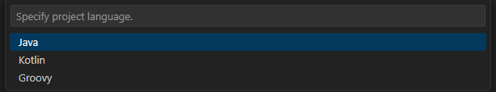

1. Set the groupID

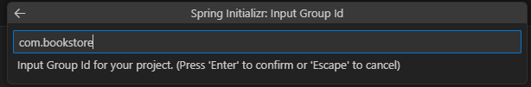

1. Set package type to Jar

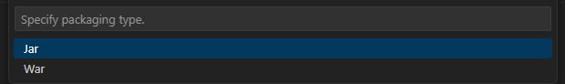

1. Add Spring Web and Thymeleaf dependencies

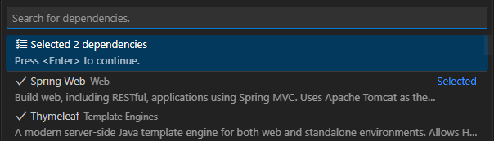

1. Modify the project description.

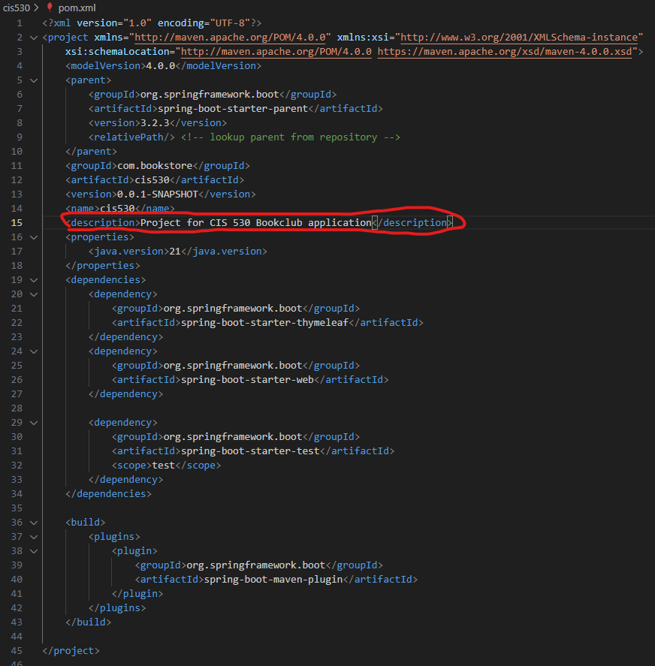

1. Create and Open index.html

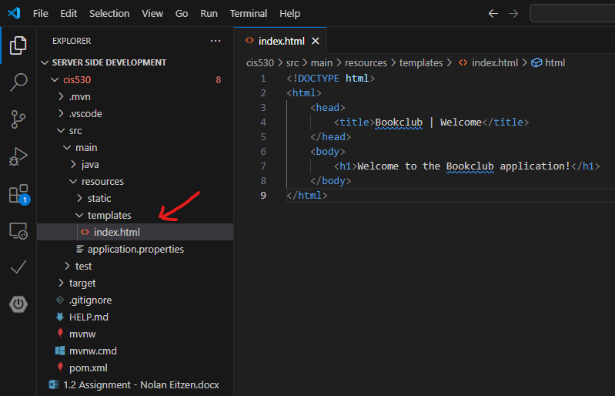

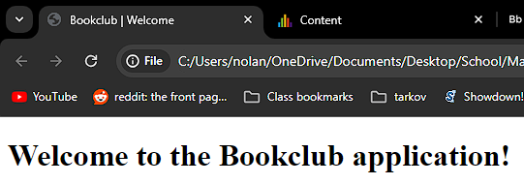

# Setting up and Syncing Github

1. Initializing the repository

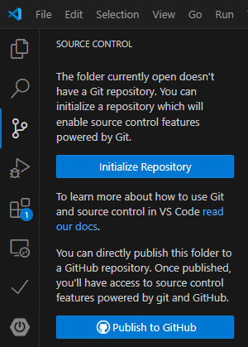

1. Committing Changes

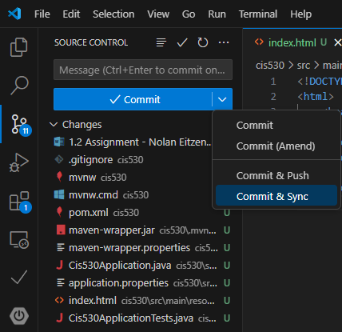

3.